

User Guide for Daryl’s Movie Emporium



Contents

Site Access 2

Register 2

Login 3

Shopping 6

Movie Selection 6

Movie Data 7

View Cart 8

Finalize the purchase 9

Empty Cart 10

# Site Access

Site access requires user registration as some pages are locked behind user credentials. Registration is the first step.

## Register

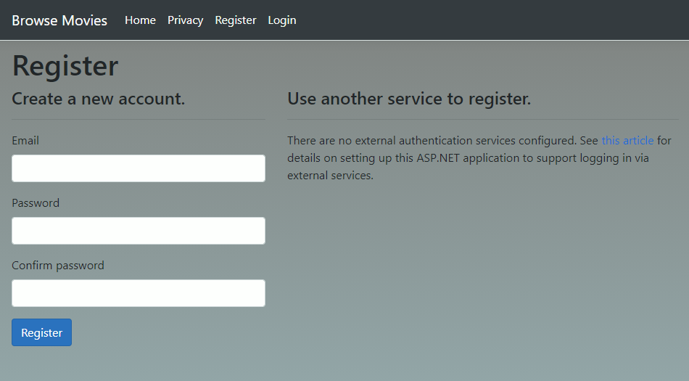

Enter your email.

Enter a password then confirm it to ensure it’s spelled properly.

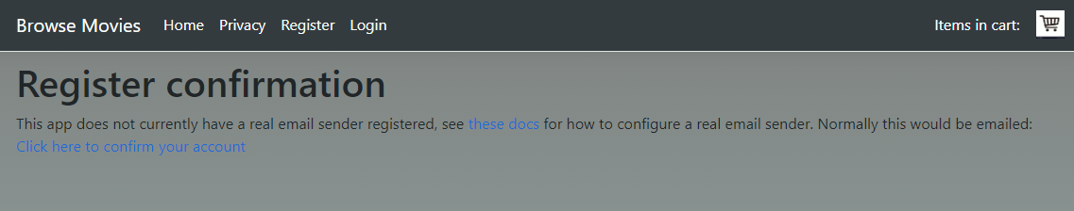

Real confirmation does not occur as this is not tied to a real store. On this page, click the confirm link to confirm your account. For a real email registration authenticator, the user would receive an email with a link to the site. When he or she clicks the link it would send the controller a token indicating that the email was received. The account would then be accessible.

At this point the user account is created. The next step is logging in.

## Login

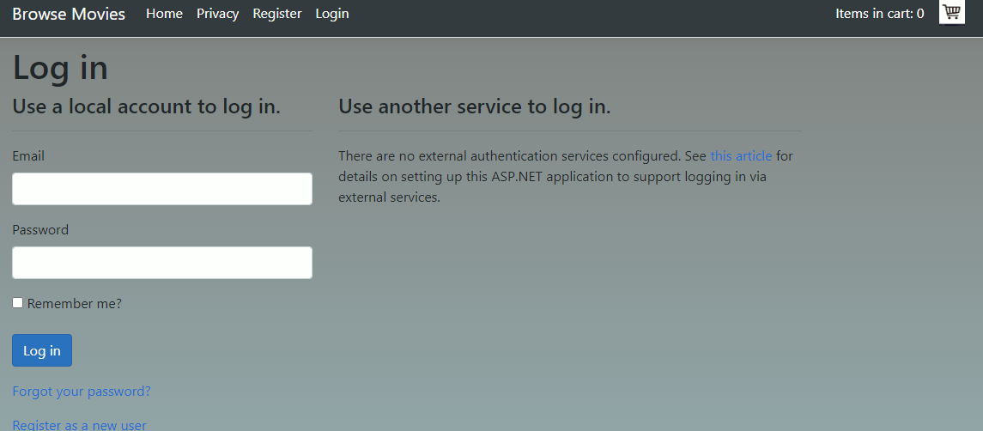

Enter the email address and password set up in the Register section.

At this point the user can either read the Privacy Policy, View an Empty cart, Browse Movies or modify his or her user account.

These options are selectable in the menu at the top.



If the user wishes to add a phone number, update his or her email, change the password, etc. click the link that says Hello <user name>.

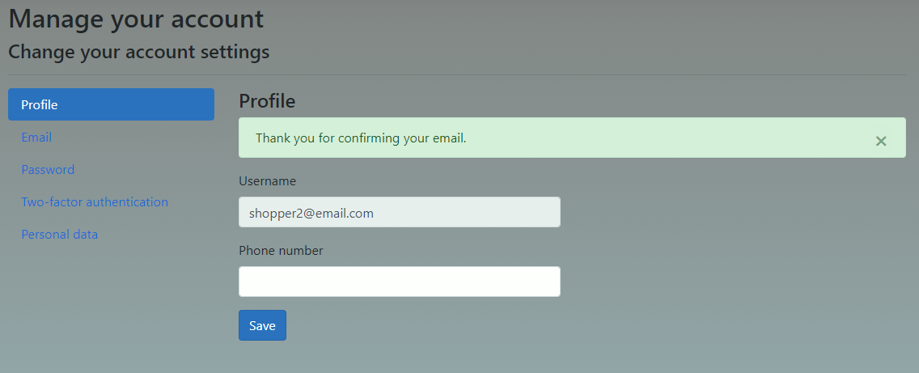

The following menu appears. At each stage the user can select the option on the left and fill out the data on the right.

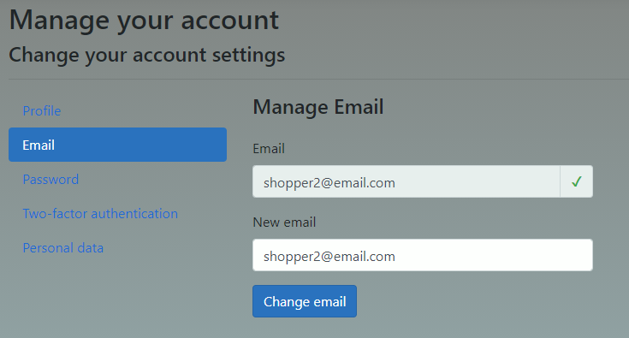

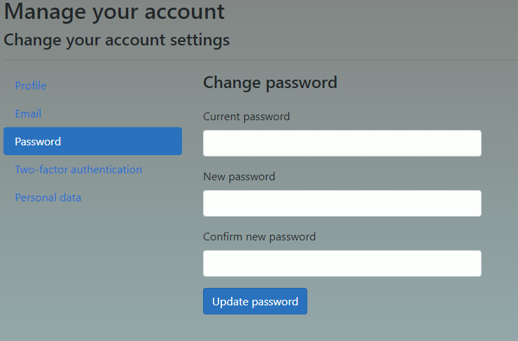

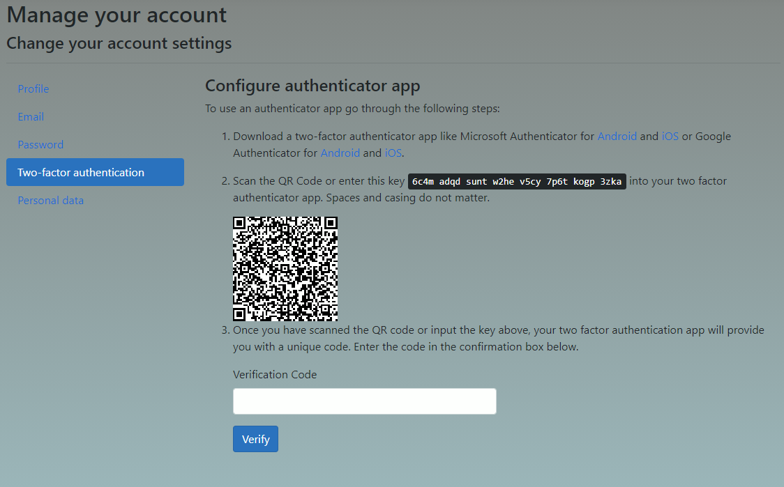

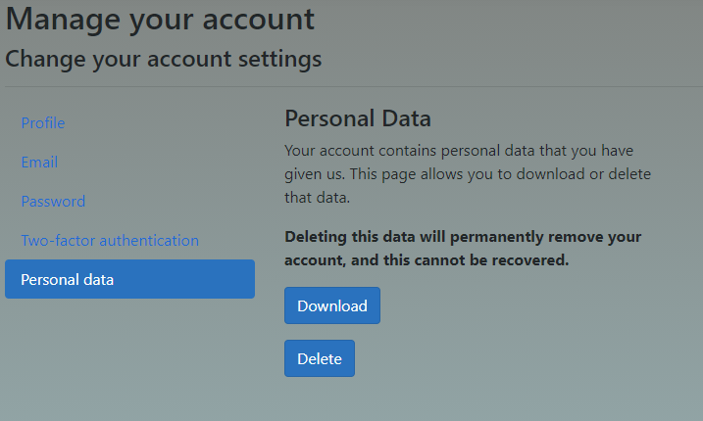

Once the user has modified or checked any desired user account settings, he or she can then read the Privacy Policy if desired, but the main draw for the site is purchasing movies.

## Shopping

Hit the Browse Movies link in the menu at the top to pull up the Genre Page. 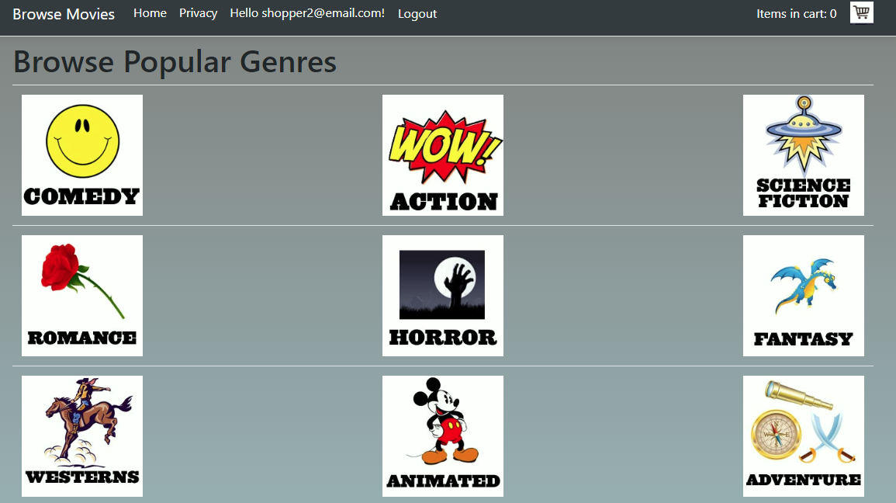

### Movie Selection

Click a genre to see a list of movies for that category.

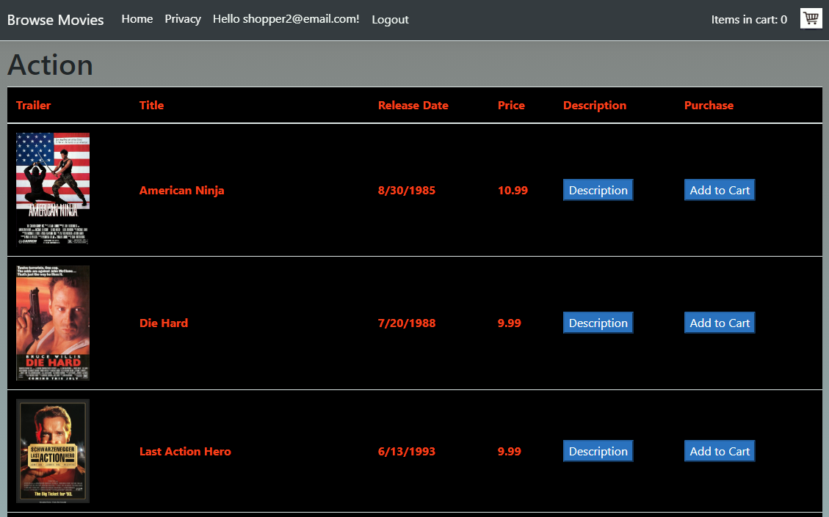

### Movie Data

Click the movie poster to see a trailer for the movie. Click the Description button to see a plot synopsis.

If the user decides to purchase, click the Add to Cart button. This will add a single copy of the selected movie to the shopping cart.

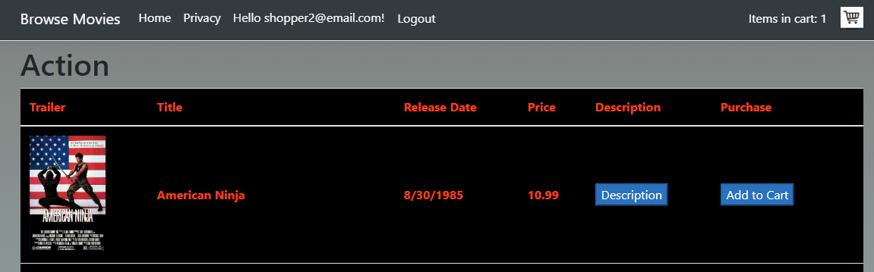

In this example, American Ninja was chosen. Note in the upper right corner the item counter shows a 1.

Click the cart icon to view the shopping cart or continue browsing this genre. To browse other genres, click the Browse Movies link at the top to return to the Genre page.

### View Cart

Click the shopping cart icon in the menu bar at any point to see the current shopping cart contents.

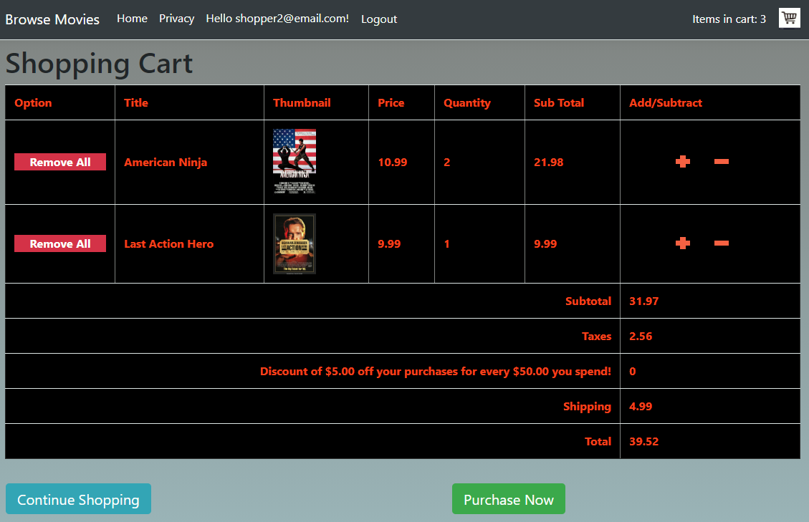

#### Adjusting the Cart

Click the red + or – buttons to add or subtract copies of movies. Remove All removes all copies of a given movie from the cart.

If the user wishes to continue shopping, click the Continue Shopping link in blue or the Browse Movies link in the menu bar at the top. This will return to the Genre page.

If, on the other hand, the user is ready to purchase, click the Purchase Now button in green. This will take the user to the Finalize Purchase page.

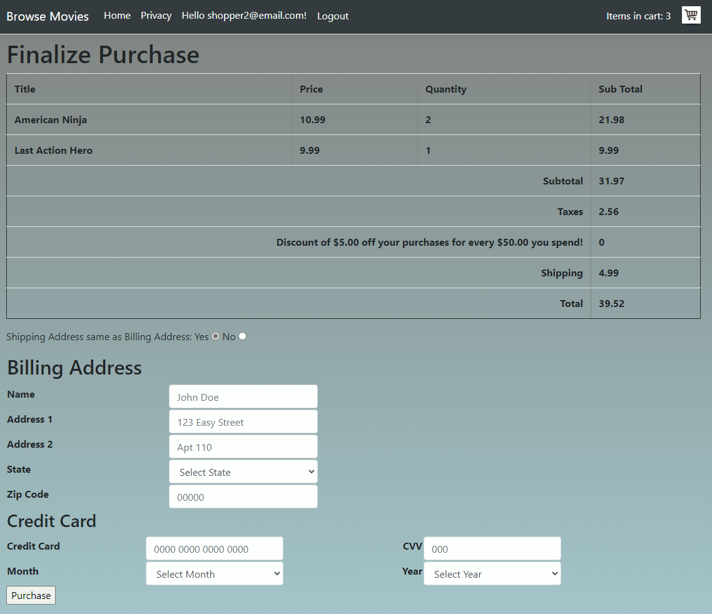

### Finalize the purchase

Here the user can enter his or her billing address and credit card information. If the purchase is a gift or has other reasons to be shipped somewhere other than the billing address, click the radio button to indicate that the shipping address is not the same as the billing address.

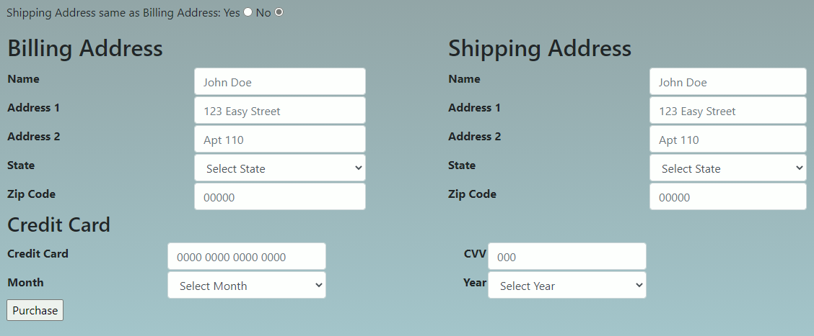

Fill out the address information and credit card information. Click Purchase to finalize the transaction, or if the user decides not to make the purchase at this point to browse the movie selection more, or to view any other pages, use the navigation menu at the top of the page.

Finally an invoice is generated for the user. This can be printed for his or her personal records.

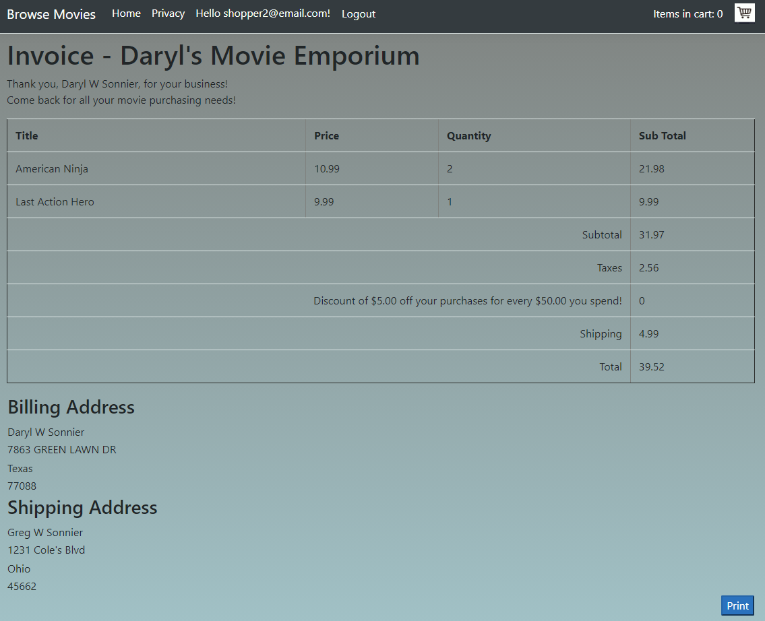

## Empty Cart

The shopping cart will automatically empty after 10 minutes of idle time or when the following occurs.

1. The user logs out.
2. The user logs in.
3. A purchase is finalized.